LabelsPlus Exports Labels to Phoenix Beverages in Mauritius

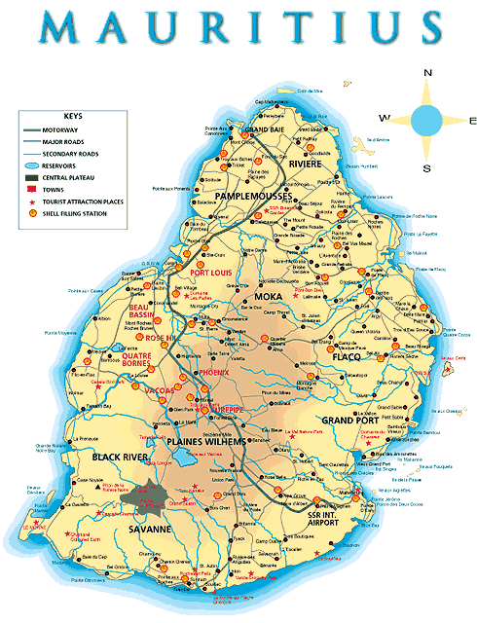

LabelsPlus have been supplying top quality labels to the water industry both nationally and internationally (in excess of 50 countries worldwide) for over 20 years. Our labels are tried and tested and are of the very best quality.

In the Mineral Water/Water Cooler industry we are renowned for our expertise as we were instrumental in the development of the face material, laminate and adhesive combination to produce our premium label construction, which is designed to last the full life of your water containers. Our labels are scratch and scuff resistant and will withstand the harsh conditions of your sterilising unit, including repeat washing up to a temperature of 70◦C. Our premium water material is available in white, silver foil or transparent options.

We are pleased to announce our latest new export customer is Mauritius based company Phoenix Beverages who ordered our premium water labels for their 18.9 litre bottles.

Phoenix Beverage were so impressed with our product that a month later they’ve ordered their second batch of our premium water labels.
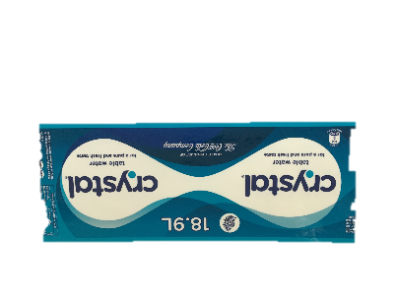
Phoenix Beverages produce and sell international brands and are the authorised bottler in Mauritius of products for The Coca-Cola Company and other household names such as Fanta, Sprite, Schweppes, Dasani and Crystal table water.

As the majority of our water labels are bespoke products, please send us your enquiry by filling the enquiry form on line and let our expert staff ring you back to discuss your requirements or if you’re unsure about the type of labels you need, please phone us on +44 (0)1663 736250. We look forward to hearing from you.

